Membership and Governance Proposal
April 10, 2014

Based on feedback and discussions following the annual Sponsor Summit, DuraSpace proposes the following iteration to the new membership/governance models:

Goals
- Aim for consistency of membership and governance structure across projects to keep things simple and clear for members while at the same time providing opportunities for sufficient “customization” to meet the needs of individual projects.
- Keep costs of administration to a minimum.
- Kick off the up-coming fund-raising period with a transition to membership while deferring changes to governance in order to give projects time to settle on the specifics of their model.
- Honor commitment, action, and merit! Let the individuals who want to help the project have an opportunity to do so.
- Allow current Sponsors (100) to easily transition to membership without confusion or needing to reassess their current level of commitment.
- Encourage new users to join as members due to added benefits, and governance participation, ideally growing the base of support for all projects and the DuraSpace organization at large.

Membership Levels
- Institutions become Members of DuraSpace. They are able to direct their membership fees to one or more projects
- Membership levels are as follows:
Membership Level | Annual Fee
Bronze | $2,500
Silver | $5,000
Gold | $10,000
Platinum | $20,000+

  - Institutions from developing nations may join as a Discounted Bronze Member for a fee of $250. A formal list of developing nations would be adopted from a standard source.
  - We will consider requests for Consortium Membership on an individual basis but will not publicize during this membership campaign.
  - The Diamond membership category will be discontinued. Individual projects may seek additional funding from Members to support specific development efforts. For example, the Fedora project will maintain its $30,000 funding level for one more year to ensure its current revenue level during the transition to membership. Institutions contributing more than $20,000 will be considered Platinum members with special recognition.
- Institutions receive DuraSpace benefits associated with their membership level. If they choose to support a specific project with their membership fees, they also receive project-specific governance benefits appropriate to their level of commitment.
Ex. 1: Institution A joins DuraSpace as a Gold Member @ $10,000 and allocates its fee to the VIVO project. Institution A will receive all DuraSpace Gold benefits and all VIVO- specific benefits at the Gold level.
Ex. 2: Institution B joins DuraSpace as a Gold Member @ $10,000 and allocates half its fee to support VIVO ($5,000) and the other half to DSpace ($5,000). Institution B will receive all DuraSpace Gold benefits, VIVO-specific governance benefits tied to their level of investment in VIVO, and DSpace-specific governance benefits appropriate to their DSpace investment.
Recommendation: Err on the side of inclusivity. If a Silver member has the time and commitment to work on behalf of the project at a level commensurate to a Gold member, we should take advantage of, and recognize, the contribution.

Membership Benefits
See Attachment A. The list of benefits does not specify a lot of detail around participation in project governance, except for some high level policies. Each project will determine the exact mapping of membership levels to the governance model. DuraSpace will work with project steering groups to resolve any extreme policy differences that emerge between projects.
Governance
See Attachment B. The following policies will apply across all projects: Will be adapted according to policies of any new projects…etc.
- The governance model for each project will include a Leadership Group representing institutions that have made significant commitments to the project, including level of membership contribution, amount of in-kind developer support (Recommendation: > 0.5 FTE/yr), or other criteria agreed to by DuraSpace. The Leadership Group determines policy on key issues presented by Steering (e.g., strategic direction, annual budget allocations). Platinum level Members will be guaranteed a seat in the Leadership Group. Gold level Members will be eligible to play a role in governance also, as determined by each project.
- A Project Steering Group will represent stakeholders in the day-to-day oversight of the project, including budget and fund-raising goals, operations, deliverables, and roadmap. Project Staff (e.g., Technical Lead, Project Director, Product Manager) will be managed by DuraSpace and will take direction from the Steering Group.
- Standing or temporary Working Groups may be formed at the discretion of the Steering Group. (Recommendation: Working Groups should be open to participation by all Members).
- Projects should strive to be inclusive with respect to elected representation in these groups
- Every member institution may participate in the nomination and election of one at-large DuraSpace Board member..
- Each Project Steering Group may choose a representative to serve on the DuraSpace board.

Attachment A.

Membership Benefits

Level | Category | Benefit
Bronze & above | Information dissemination | Annual review webinar for members
Bronze & above | Information dissemination | Member organizations will receive advanced news of project announcements and activities
Bronze & above | General | Project Member logo for member use
Bronze & above | General | Institution name and link on the DuraSpace and Project web sites
Bronze & above | Governance | Eligible to vote on an at-large Member representative to the DuraSpace board of directors
Bronze & above | Governance | Recommendation: Eligibility to sit on Working Groups
 |  | All the above benefits, plus:
Silver & above | General | Institution name, logo and link on the DuraSpace and Project web sites
Silver & above (for 1st year of sponsorship) | Discounts/Special Feature Access | 10% discount to new members on first year of either DSpaceDirect or DuraCloud
Silver & above | Discounts/ | Discounted registration at project training events
 |  | All the above benefits, plus:
Gold & above | Events | Preferred access (advance registration) to DuraSpace professional development opportunities
Gold & above | Events | Annual membership summit / strategic forum on projects with DuraSpace; presentations and networking with leaders from prominent institutions and projects
Gold & above | Governance | Eligible to play a role in project governance, as defined by each project’s governance policy
 |  | All the above benefits, plus:
Platinum | Governance | Eligible for one seat on Project Leadership Group

Other Exclusive Benefits or Membership:
- Eligibility to participate in pilot projects and early adopter support

Non-Exclusive Benefits supported by DuraSpace members:
- New releases
- Documentation
- Continuous integration
- Security patches

Attachment B
Project Governance Template

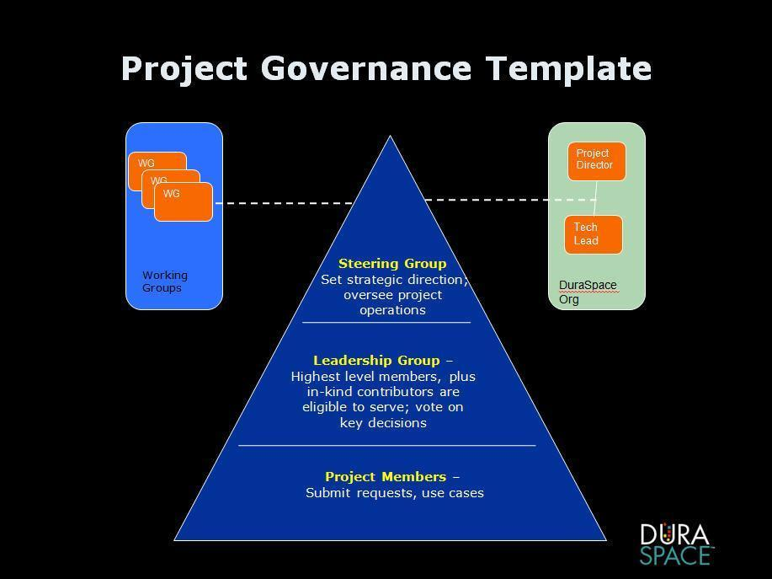

Institutions that enter basic information about their implementation in the online project registry will receive security bulletins in advance of the public lists.

