Medium of Performance. Part 1

Scope of document

This document describes basic modeling of medium of performance in PMO. Further extensions and refinements may be found in Part 2 of the document.

Modelling Medium in PMO

Relationship to LC classes/properties for Medium of performance
PMO does not use any of the music-related classes or properties defined in BIBFRAME. These were put into BIBFRAME to allow experimentation with medium of performance, in the absence of a more worked out model that would reside in an extension rather than BIBFRAME proper. The modelling presented is based heavily on work done by the MLA Linked Data Working Group (LuDWiG), Doremus, and especially Kimmy Szeto, who originally spearheaded this effort. It represents, for the most part, the use cases collected by the LuDWiG.

Classes & properties for medium of performance
The two basic classes for medium in PMO are pmo:DeclaredMedium and pmo:PerformedMedium, modeling the division of what a composer intended versus the medium that is actually used in a particular performance. All other details hang off these two classes. The class pmo:PerformedMedium is associated only with performance-oriented Work subclasses of bf:Audio, and bf:Video (or bf:Work if these subclasses are not being used), or with bf:Event since it details medium of performance as used in a performance. The class pmo:DeclaredMedium is associated primarily with bf:NotatedMusic and bf:Work (when used as a FRBR or IFLA-LRM entity or similar capacity as in RDA (see Works document)), but may also appear in bf:Audio if the written material on the container states the declared medium. The metadata will be duplicative in these pairings. The diagrams here use bf:NotatedMusic and bf:PerformedMusic throughout, but may be used with the alternatives stated above as well. One property, pmo:hasMedium connects the declared or performed medium to the relevant work.

Term | Type | Definition
pmo:DeclaredMedium | Class | Intended overall medium of performance of a musical work, as declared by the composer, a reference source, or other source.
pmo:PerformedMedium | Class | The overall medium of performance used in the performance of a musical work. This may or may not be the same as the declared medium of performance.
pmo:hasMedium | property | Property that links a Work or Performance to the declared or performed medium.

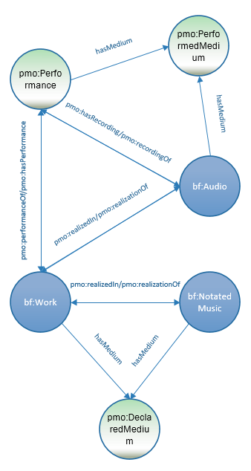

pmo:PerformedMedium in association with pmo:Performance & bf:Audio; pmo:DeclaredMedium in association with bf:Work/bf:NotatedMusic. Relationships between event and work classes is covered in the Works paper. (not yet available).
In later diagrams, this will be simplified to the use of bf:Audio and bf:NotatedMusic for clarity.

Each pmo:DeclaredMedium or pmo:PerformedMedium has at least one pmo:MediumPart linked to it by the property pmo:hasMediumPart. There is one pmo:MediumPart for each individual medium of performance for a declared or performed medium (e.g., pi pa; clarinets; orchestra).
Each of these elements are then declared in the class pmo:MediumOfPerformance, or its subclasses pmo:IndividualMediumOfPerformance and pmo:EnsembleMediumOfPerformance. They are linked to pmo:MediumPart by pmo:hasMediumOfPerformance (abbreviated in diagrams to pmo:hasMOP).

Class | Definition | Subclass of
pmo:MediumPart | Medium of performance, type, etc., of a specific part of the declared medium
pmo:MediumOfPerformance | Instruments, voices, ensembles, choruses, and other participants (actors, dancers, etc.) required or used in event content or in a work, including electronics, computers, installations, etc.
pmo:EnsembleMediumOfPerformance  may be abbreviated as pmo:EnsembleMOP in diagrams | Named group of like or unlike mediums of performance intended to be played by multiple performers, e.g., orchestra, jazz combo, string quartet, percussion ensemble. | pmo:MediumOfPerformance
pmo:IndividualMediumOfPerformance  may be abbreviated as pmo:IndividualMOP in diagrams | Individual musical instrument, voice, or other object used as a medium of performance (e.g., flute, keyboards, pi pa, synthesizer, bass guitar, or group of instruments, e.g., percussion, intended to be played by a single performer. | pmo:MediumOfPerformance

Property | Definition | Use with | Expected value
pmo:hasMediumPart | Specific element within an overall declared or performed medium | bf:DeclaredMedium, bf:PerformedMedium | pmo:MediumPart
pmo:hasMediumOfPerformance  may be abbreviated as pmo:hasMOP in diagrams | Specific medium of performance | pmo:MediumPart | pmo:MediumOfPerformance (and subclasses)

Also linked to pmo:PerformedMedium, pmo:DeclaredMedium, and pmo:MediumPart are various counts; the total number of distinct music parts (e.g., bass guitar; er hu; 2 shawms; percussion); the total number of required performers (e.g., a percussion ensemble that requires 8 performers); and/or the total number of ensemble mediums (e.g., women’s chorus; jazz combo).
This makes for an intensive number of counts—on the declared medium, on the performed medium, and on each medium part—in order to address our current user requirements. Some may be dropped or adapted as familiarity with the linked data environment evolves.

Property | Definition | Use with | Expected value
pmo:hasDistinctPartCount  abbreviated as pmo:hasDPC in diagrams | Number of distinct music parts in a performed or declared medium, or medium part that is not a named ensemble, e.g, a performed work for 2 flutes and bassoon has a count of “3”. | pmo:DeclaredMedium, pmo:PerformedMedium,  pmo:MediumPart | literal
pmo:hasRequiredPerformerCount  abbreviated as pmo:hasRPC in diagrams | Minimum number of performers required to perform a declared medium, e.g., a work for percussion trio has a a count of “3”. | pmo:DeclaredMedium, pmo:MediumPart | literal
pmo:hasEnsembleCount  abbreviated as pmo:hasEC in diagrams | Number of named ensembles in a specified declared or performed medium, e.g., a string quartet has a count of “1”; a jazz combo has a count of “1”; a work for 2 choruses and orchestra has a count of “3”. | pmo:DeclaredMedium, pmo:PerformedMedium, pmo:MediumPart | literal
pmo:hasPerformerCount  abbreviated as pmo:hasPC in diagrams | Actual number of performers participating in a performed music event or work, e.g., a quartet for 4 serpents, performed by 8 bassoons, has a count of "8". | pmo:PerformedMedium, pmo:MediumPart, pmo:MusicPart | literal

The preferred value for a count is an integer. It will happen, however, that a count is approximate in some way (“for 3 and any number more performers; for 2-4 performers”) and should be entered as such, according to developing best practices.
The following diagram models pmo:PerformedMedium and pmo:DeclaredMedium for an individual instrument, which is the same in both cases. It also models a performer count for the performed work and a required performer count for the declared work, which again are the same as all the other counts:
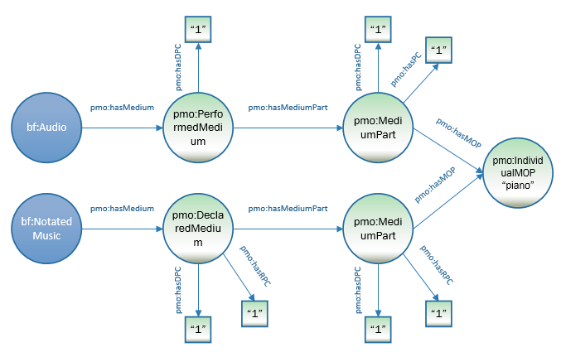

:a1 a bf:Audio ;
pmo:hasMedium [
a pmo:PerformedMedium ;
pmo:hasDistinctPartCount “1” ;
pmo:hasMediumPart [
a pmo:MediumPart ;
pmo:hasMediumOfPerformance <http://id.loc.gov/authorities/performanceMediums/mp2013015550> ;
pmo:hasDistinctPartCount "1" ;
pmo:hasPerformerCount "1" ] ;
] .
:n1 a bf:NotatedMusic ;
a pmo:DeclaredMedium ;
pmo:hasDistinctPartCount “1” ;
pmo: hasRequiredPerformerCount “1” ;
pmo: hasMediumPart [
a pmo:MediumPart ;
pmo:hasMediumOfPerformance <http://id.loc.gov/authorities/performanceMediums/mp2013015550> ;
pmo:hasDistinctPartCount "1" ;
pmo:hasRequiredPerformerCount "1" ] ;
] .

<http://id.loc.gov/authorities/performanceMediums/mp2013015550> a pmo:IndividualMediumOfPerformance ;
rdfs:label "piano" .

The same model applies if there is more than one performer, but only one type of medium, whether an individual instrument/voice or ensemble. This diagram models a work for 3 flutes, in which each flute has a distinct part (the modelling of the distinct parts individually is addressed in Medium of performance. Part 2).
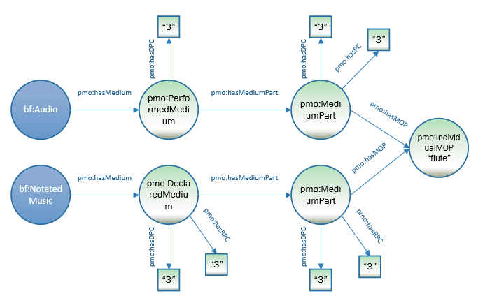

:a1 a bf:Audio ;
pmo:hasMedium [
a pmo:PerformedMedium ;
pmo:hasDistinctPartCount “3” ;
pmo:hasMediumPart [
a pmo:MediumPart ;
pmo:hasMediumOfPerformance <http://id.loc.gov/authorities/performanceMediums/mp2013015268> ;
pmo:hasDistinctPartCount "3" ;
pmo:hasPerformerCount “3” ] ;
] .
:n1 a bf:NotatedMusic ;
pmo:hasMedium [
a pmo:DeclaredMedium ;
pmo:hasDistinctPartCount “3” ;
pmo:hasRequiredPerformerCount “3” ;
pmo:hasMediumPart [
a pmo:MediumPart ;
pmo:hasMediumOfPerformance <http://id.loc.gov/authorities/performanceMediums/mp2013015268> ;
pmo:hasDistinctPartCount "3" ;
pmo:hasRequiredPerformerCount “3” ] ;
] .

<http://id.loc.gov/authorities/performanceMediums/mp2013015268> a pmo:IndividualMediumOfPerformance ;
rdfs:label "flute" .

If there is only one distinct part, such as with a work for solo flute, but the performance has 3 flutes playing that one part in unison, the model would look like this:

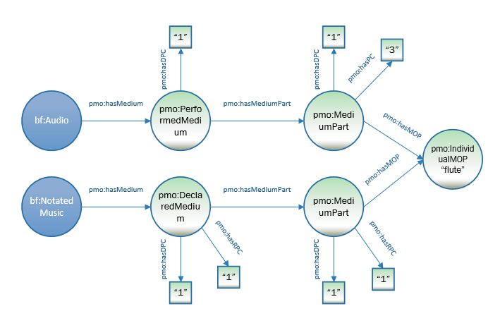

The basic model may also be applied to a named ensemble:

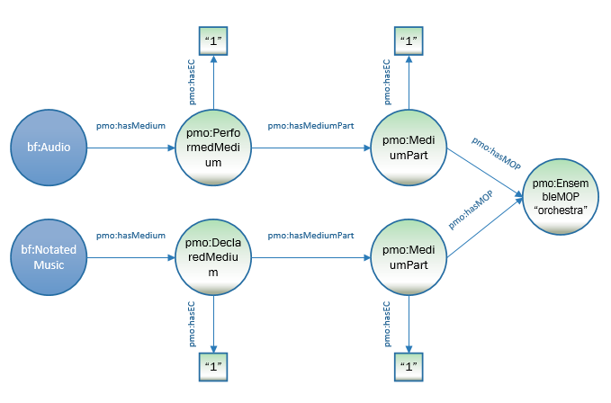

:a1 a bf:Audio ;
pmo:hasMedium [
a pmo:PerformedMedium ;
pmo:hasEnsembleCount “1” ;
pmo: hasMediumPart [
a pmo:MediumPart ;
pmo:hasMediumOfPerformance <http://id.loc.gov/authorities/performanceMediums/mp2013015516> ;
pmo:hasEnsembleCount "1" ] ;
] .
:n1 a bf:NotatedMusic ;
pmo:hasMedium [
a pmo:DeclaredMedium ;
pmo:hasDistinctPartCount “1” ;
pmo:hasMediumPart [
a pmo:MediumPart ;
pmo:hasMediumOfPerformance <http://id.loc.gov/authorities/performanceMediums/mp2013015516> ;
pmo:hasEnsembleCount "1" ] ;
] .

<http://id.loc.gov/authorities/performanceMediums/mp2013015516> a pmo:EnsembleMediumOfPerformance ;
rdfs:label "orchestra" .

Note that an ensemble has a pmo:hasEnsembleCount, rather than pmo:hasDistinctPartCount. Also, there is no pmo:requiredPerformerCount or pmo:performerCount, since these are either not exact numbers or are unknown.

In the following diagram, the declared medium is “recorder”, but the performance is done on a flute:

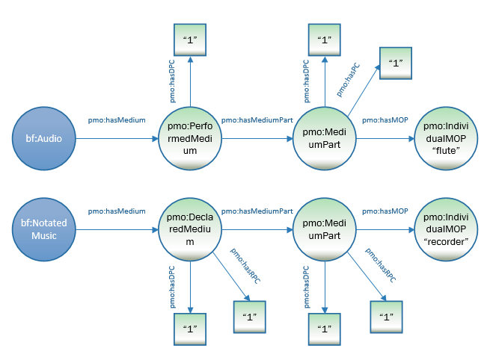

:a1 a bf:Audio ;
pmo:hasMedium [
a pmo:PerformedMedium ;
pmo:hasDistinctPartCount “1” ;
pmo:hasMediumPart [
a pmo:MediumPart ;
pmo:hasMediumOfPerformance <http://id.loc.gov/authorities/performanceMediums/mp2013015268> ;
pmo: hasDistinctPartCount "1" ;
pmo:hasPerformerCount "1" ] ;
] .

<http://id.loc.gov/authorities/performanceMediums/mp2013015268> a pmo:IndividualMediumOfPerformance ;
rdfs:label "flute" .

:n1 a bf:NotatedMusic ;
a pmo:DeclaredMedium ;
pmo:hasDistinctPartCount “1” ;
pmo:hasRequiredPerformerCount “1” ;
hasMediumPart [
a pmo:MediumPart ;
pmo:hasMediumOfPerformance <http://id.loc.gov/authorities/performanceMediums/mp2013015597> ;
pmo:hasDistinctPartCount "1" ;
pmo:hasRequiredPerformerCount "1" ] ;
] .

<http://id.loc.gov/authorities/performanceMediums/mp2013015597> a pmo:IndividualMediumOfPerformance ;
rdfs:label "recorder" .

The following diagram models a trio for 2 flutes and a cello. The modeling is for 2 separate mediums of performance that make up the performed medium, with a total count of 3 distinct parts, the count for which hangs off pmo:PerformedMedium as an pmo:distinctPartCount. Both medium parts have counts as well, in this diagram a pmo:hasPerformerCount.

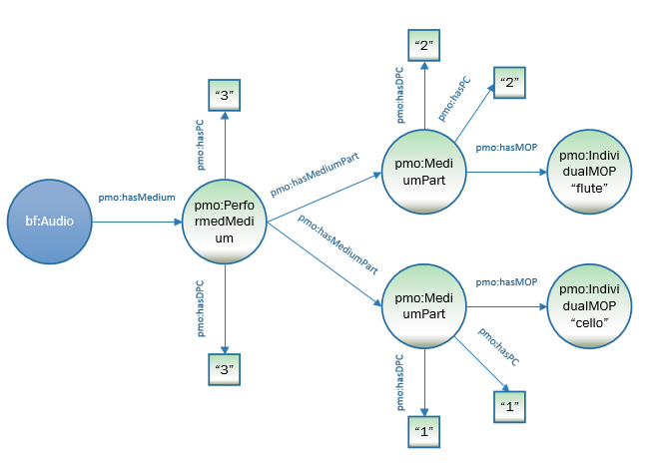

:a1 a bf:Audio ;
pmo:hasMedium [
a pmo:PerformedMedium ;
pmo:hasDistinctPartCount “3” ;
pmo:hasPerformerCount “3” ;
pmo:hasMediumPart [
a pmo:MediumPart ;
pmo:hasMediumOfPerformance<http://id.loc.gov/authorities/performanceMediums/mp2013015268> ;
pmo:hasDistinctPartCount "2" ;
pmo:hasPerformerCount “2” ] ;
pmo:hasMediumPart [
a pmo:MediumPart ;
pmo:hasMediumOfPerformance <http://id.loc.gov/authorities/performanceMediums/mp2013015120> ;
pmo:hasDistinctPartCount "1" ;
pmo:hasPerformerCount “1” ] ;
] .

<http://id.loc.gov/authorities/performanceMediums/mp2013015268> a pmo:IndividualMediumOfPerformance ;
rdfs:label "flute" .

<http://id.loc.gov/authorities/performanceMediums/mp2013015120> a pmo: IndividualMediumOfPerformance ;
rdfs:label "cello" .

The following diagram is for a work for 3 ensembles—an orchestra, a mixed chorus, and a children’s chorus.

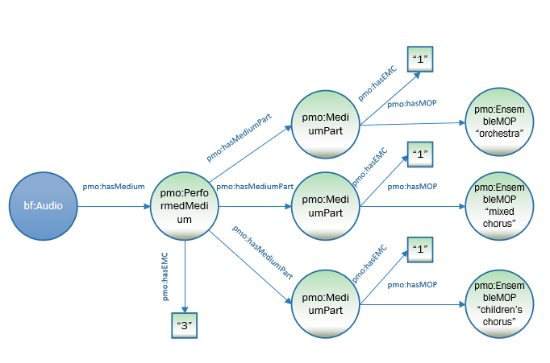

:a1 a bf:Audio ;
pmo:hasMedium [
a pmo:PerformedMedium ;
pmo:hasEnsembleCount “3” ;
pmo:hasMediumPart [
a pmo:MediumPart ;
pmo:hasMediumOfPerformance <http://id.loc.gov/authorities/performanceMediums/mp2013015516> ;
pmo:hasEnsembleCount "1" ] ;
pmo:hasMediumPart [
a pmo:MediumPart ;
pmo:hasMediumOfPerformance <http://id.loc.gov/authorities/performanceMediums/mp2013015143> ;
pmo:hasDistinctPartCount "1" ] ;
pmo:hasMediumPart [
a pmo:MediumPart ;
pmo:hasMediumOfPerformance <http://id.loc.gov/authorities/performanceMediums/mp2013015135> ;
pmo:hasDistinctPartCount "1" ] ;
] .

<http://id.loc.gov/authorities/performanceMediums/mp2013015516> a pmo:EnsembleMediumOfPerformance ;
rdfs:label "orchestra" .

<http://id.loc.gov/authorities/performanceMediums/mp2013015143> a pmo: EnsembleMediumOfPerformance ;
rdfs:label "chorus" .

<http://id.loc.gov/authorities/performanceMediums/mp2013015135> a pmo: EnsembleMediumOfPerformance ;
rdfs:label "children's chorus" .

