Medium of Performance. Part 2

The document Medium of Performance, Part 1 covered the basic model of medium of performance in PMO. Part 2 extends and refines that model.

Modeling Alternate Representations of Ensembles

Sometimes there is a need or desire to model ensembles, especially smaller ones, as both the ensemble as a whole and by its constituent medium parts—alternate representations of the same ensemble. As with alternated mediums, it is more straight forward to create two declared and/or performed mediums; These are then related to the pmo:PerformedMedium/DeclaredMedium with the property pmo:hasAlternatelyRepresentedMedium.
The following diagram shows the modeling of a piano trio as a pmo:PerformedMedium, indicating both the ensemble and constituent parts (including count). A pmo:DeclaredMedium for a piano trio would be modeled in the same way. The pmo:MediumOfPerformance for the bf:PerformedMedium is optional, but permits searching both at the level of the ensemble and its consitutent parts. Note the difference in count between the two representations
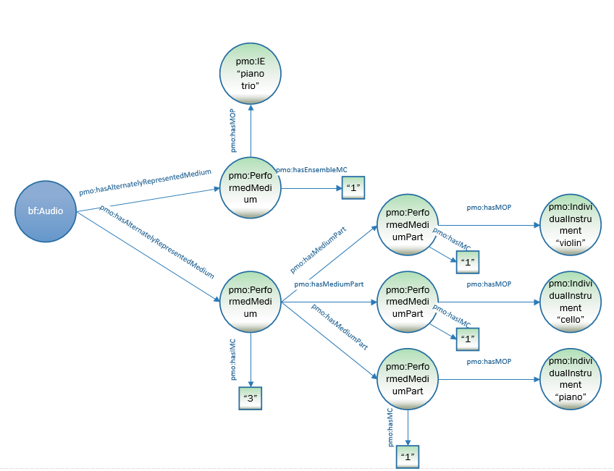

:a1 a bf:Audio ;
pmo:hasAlternatelyRepresentedMedium [
a pmo:PerformedMedium ;
pmo:hasEnsembleMediumCount “1” ;
pmo:hasMediumOfPerformance [
a pmo:InstrumentEnsemble ;
rdfs:label “piano trio” ] ;
] ;
pmo:hasAlternatelyRepresentedMedium [
a pmo:PerformedMedium ;
pmo:hasIndividualMediumCount "3" ;
pmo:hasMediumPart [
a pmo:MediumPart ;
pmo:hasMediumOfPerformance [
a pmo:IndividualInstrument ;
rdfs:label “violin” ] ;
pmo:hasIndividualMediumCount “1” ] ;
pmo:hasMediumPart [
a pmo:MediumPart ;
pmo:hasMediumOfPerformance [
a pmo:IndividualInstrument ;
rdfs:label “cello” ] ;
pmo:hasIndividualMediumCount “1” ] ;
pmo:hasMediumPart [
a pmo:MediumPart ;
pmo:hasMediumOfPerformance [
a pmo:IndividualInstrument ;
rdfs:label “piano” ] ;
pmo:hasIndividualMediumCount “1” ] ;
] .

Modeling Music Parts
In some cases, a cataloger may want a pmo:MediumPart further subdivided, indicating musical parts (e.g., Violin 1, Clarinet 2), usually to link a specific performer to a specific part. The most obvious example of this might be in the performance of a string quartet, where the roles of the 2 violins are quite different.

Property | Definition | Domain | Range
pmo:hasMusicPart | The specific music parts within a single medium part e.g., Violin 1, Clarinet 2. | pmo:DeclaredMedium, bf:Contribution (see Part 3) | literal

The following diagram shows the modeling of the Violin 1 & Violin 2 parts of a string quartet (viola & cello are omitted). The pmo:DeclaredMediumPart has a pmo:IndividualInstrument with the value “violin” and a count of 2. It also has two pmo:MusicPart nodes associated with it for Violin 1 and Violin 2. The turtle describes the entire string quatet. For joining this model with performers, see the Contribution paper (not yet available).

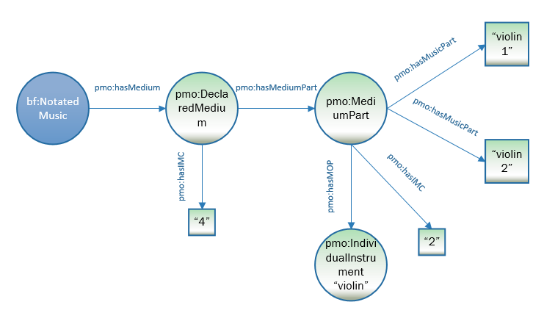
:n1 a bf:NotatedMusic ;
pmo:hasMedium [
a pmo:DeclaredMedium ;
pmo:hasMediumCount “4” ;
pmo:hasMediumPart [
a pmo:MediumPart ;
pmo:hasInstrumentMediumCount "4"
pmo:hasMediumOfPerformance [
a pmo:IndividualInstrument ;
rdfs:label “violin” ] ;
pmo:hasMusicPart “Violin 1” ;
pmo:hasMusicPart “Violin 2” ] ;
pmo:hasMediumPart [
a pmo:MediumPart ;
pmo:hasInstrumentMediumCount "4"
pmo:hasMediumOfPerformance [
a pmo:IndividualInstrument ;
rdfs:label “viola” ] ;
] ;
pmo:hasMediumPart [
a pmo:MediumPart ;
pmo:hasInstrumentMediumCount "4"
pmo:hasMediumOfPerformance [
a pmo:IndividualInstrument ;
rdfs:label "cello" ] ;
] ;
] .

Modeling medium part types
A declared or performed medium part may be labelled as a certain type of part—solo, optional, ad lib, divisi. These are indicated by the property pmo:mediumPartType and the class pmo:MediumPartType.

Class | Definition | Subclass of
pmo:MediumPartType | A pmo:MediumPart with specific role or type of part, e.g., solo, ad lib, optional, offstage

Property | Definition | Use with: | Range
pmo:hasMediumPartType | The type of pmo:MediumPart, e.g., solo, ad lib, optional, offstage | pmo:DeclaredMedium | pmo:MediumPartType

The following diagram models a pmo:PerformedMedium for solo bassoon and orchestra. Note that pmo:DeclaredMedium has both a pmo:IndividualMediumCount (the bassoon) and a pmo:EnsembleCount (the orchestra).
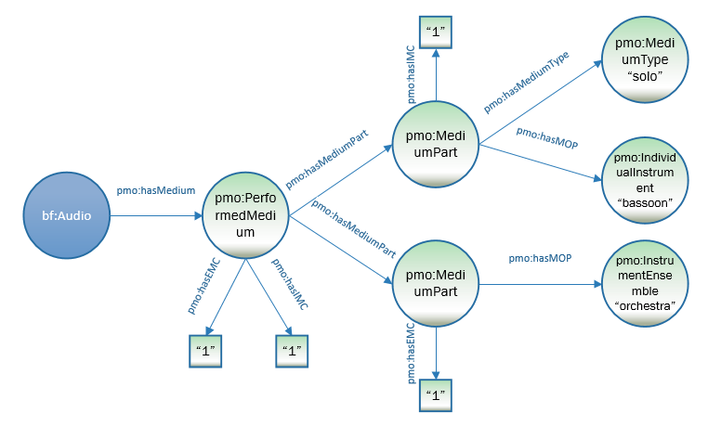

:a1 a bf:NotatedMusic ;
pmo:hasMedium [
a pmo:DeclaredMedium ;
pmo:hasMediumPart [
a pmo:MediumPart ;
pmo:hasMediumCount “1” ;
pmo:hasMediumOfPerformance [
a pmo:IndividualInstrument ;
rdfs:label “bassoon” ;
pmo:hasMediumType “solo “ ] ;
] ;
pmo:hasMediumPart [
a pmo:MediumPart ;
pmo:hasMediumOfPerformance [
a pmo:Ensemble ;
rdfs:label “orchestra” ] ;
pmo:hasMediumCount “1” ] ;
] .

Modeling doubling media

Doubling is the single case in which a pmo:DeclaredMedium or pmo:PerformedMedium may have more than one medium of performance, since the media are conceived as one musical unit.

Property | Subproperty of: | Definition
pmo:hasDoublingMediumOfPerformance | pmo:hasMediumOfperformance | 2 (or more) media of performance intended to be performed alternately by a single performer

The following diagram models 2 flutes, 1 of which doubles piccolo.
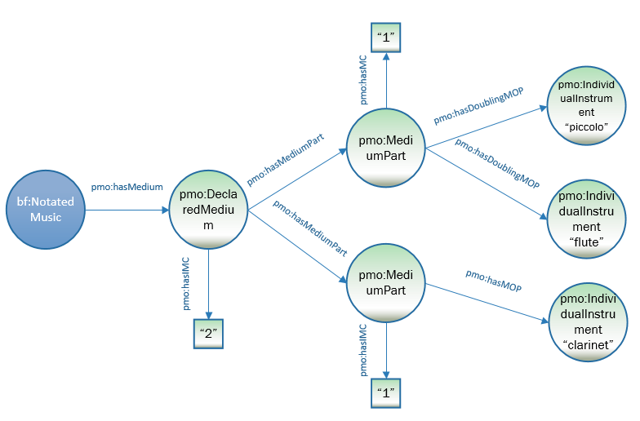
:a1 a bf:NotatedMusic ;
pmo:hasMedium [
a pmo:DeclaredMedium ;
pmo:hasMediumPart [
a pmo:DeclaredMediumPart ;
pmo:hasMediumCount “1” ;
pmo:hasDoublingMediumOfPerformance [
a pmo:IndividualInstrument ;
rdfs:label “flute” ] ;
pmo:hasDoublingMediumOfPerformance [
a pmo:IndividualInstrument ;
rdfs:label “piccolo” ] ;
] ;
pmo:hasMediumPart [
a pmo:MediumPart ;
pmo:hasMediumOfPerformance [
a pmo:IndividualInstrument ;
rdfs:label “flute” ] ;
pmo:hasMediumCount “1” ] ;
] .

Modeling alternate media
In some musical works, the composer, arranger, etc. offers a choice of music media, whether in its entirety (e.g., “for organ or string orchestra”), for a single instrument (e.g., “for flute or violin and cello), or for a group of instruments (e.g., “for 2 flutes or 2 violins and cello). This is modeled with the class pmo:AlternateMediumPart, a subclass of pmo:DeclaredMedium; they always come in twos at least. The symmetrical property pmo:alternateOf pairs the alternates.

Class | Definition | Subclass of:
pmo:AlternateMediumPart | A declared medium part in which one more of the medium parts offers a choice between mediums. Always comes as a pair. | pmo:DeclaredMedium

Property | Subproperty of: | Definition
pmo:alternateOf |  | Mediums of performance that are declared as alternates for each other.

A work for bassoon or cello:
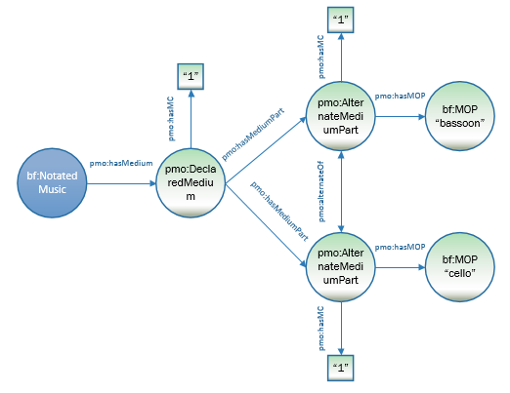
:w1 a bf:Audio ;
pmo:hasMedium [
a pmo:DeclaredMedium ;
pmo:hasIndividualMediumCount "1" ;
pmo:hasMediumPart :a1 ;
pmo:hasMediumPart :a2 .
:a1 a pmo:AlternateMediumPart ;
pmo:hasMediumOfPerformance [
a pmo:IndividualInstrument ;
rdfs:label "bassoon" ;
pmo:individualMediumCount "1" ;
pmo:alternateOf :a2 ] .
:a2 a pmo:AlternateMediumPart ;
pmo:hasMediumOfPerformance [
a pmo:IndividualInstrument ;
rdfs:label "cello" ;
pmo:individualMediumCount "1" ;
pmo:alternateOf :a1 ] .

A work for 2 violins and cello or flute, violin, and cello:

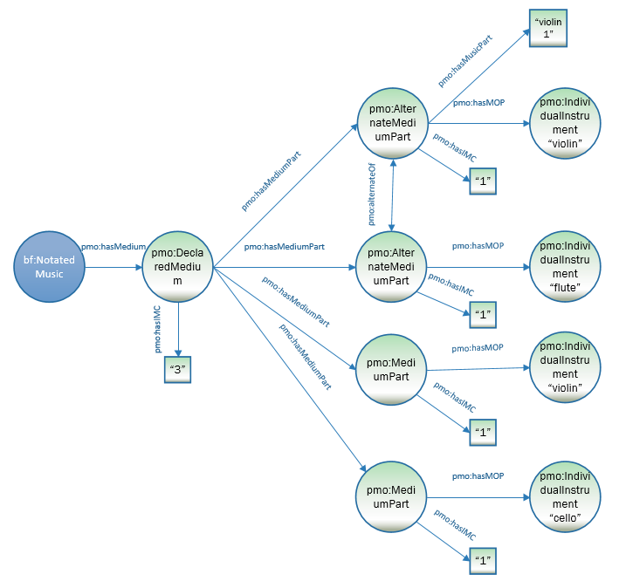
:w1 a bf:Audio ;
pmo:hasMedium [
a pmo:DeclaredMedium ;
pmo:hasIndividualMediumCount "3" ;
pmo:hasMediumPart :a1 ;
pmo:hasMediumPart :a2 ;
pmo:hasMediumPart :a3 ;
pmo:hasMediumPart :a4 .
:a1 a pmo:AlternateMediumPart ;
pmo:hasMediumOfPerformance [
a pmo:IndividualInstrument ;
rdfs:label "violin" ;
pmo:individualMediumCount "1" ;
pmo:alternateOf :a2 ] .
:a2 a pmo:AlternateMediumPart ;
pmo:hasMediumOfPerformance [
a pmo:IndividualInstrument ;
rdfs:label "flute" ;
pmo:individualMediumCount "1" ;
pmo:alternateOf :a1 ] .
:a3 a pmo:MediumPart ;
pmo:hasMediumOfPerformance [
a pmo:IndividualInstrument ;
rdfs:label "violin" ;
pmo:individualMediumCount "1" ] .
:a4 a pmo:MediumPart ;
pmo:hasMediumOfPerformance [
a pmo:IndividualInstrument ;
rdfs:label "cello" ;
pmo:individualMediumCount "1" ] .

Note here that the model does not ever state “2 violins”, but rather one violin or flute, another violin, and cello. This is one weakness to the model that is difficult to overcome.

