Works, Part 2. Compilations

Scope of document & Introduction

This document describes very basic modeling of aggregate works, specifically compilations, in PMO. Unlike books and many other library resources, sound recordings and music videos are more likely to be compilations than not. For example, a typical CD of popular music will contain about 10 songs, all of which would be considered individual works in several different data models. These same recordings of the songs may then appear in multiple other compilations or alone, such as in a digitally streamed song. Because of the prevalence of compilations, no ontology for performed music can be complete without addressing their modeling. PMO does this somewhat reluctantly, for compilations affect far more than sound recordings alone.
The two hypothetical models presented here address only the most basic aspects of compilation necessary for PMO to function; there is no intention that they cover every possibility. They are intended to serve as a basis for discussion of modeling compilations in a linked data environment. It is hoped that further input from the library community and the evolution of library models for compilations will enrich and vastly improve it over time.

Modelling Compilations in PMO

PMO is based on BIBFRAME 2.0 and is intended primarily for library-type data in the library community. Because of this, the creators of the ontology attempted to stay as close as possible to standardized library conceptual models, initially Functional requirements of bibliographic records (FRBR) and now IFLA-LRM (IFLA-Library Reference Model). Our two possible compilations models are based on that in IFLA-LRM as we understand it, with some additions/modifications to meet our user needs and linked data modeling. The use of IFLA-LRM does not necessarily mean that all members of the PMO team agree with the model, but it was generally felt that sticking close to an international standard was the best way to start.

The IFLA-LRM model
The IFLA-LRM model for compilation-type aggregates is summarized in the following diagram:
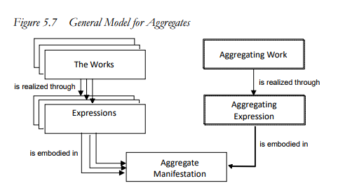
General model for Aggregates from IFLA Library Reference Model, p. 92.
Compilations in IFLA-LRM are described as “Aggregate Collections of Expressions”. Collections are defined as “sets of multiple independently created expressions which are ‘published’ together in a single manifestation”. The primary thing to note from these definitions is that according to IFLA-LRM, compilation happens at the expression level (BIBFRAME=bf:Audio). This aggregation then creates an aggregating expression which in turn creates an aggregating work. The individual expressions are “embodied” in the aggregate manifestation, but are independent of the aggregating expression/work—it is not a whole-part relationship. A “short-cut” modeling of this in IFLA-LRM is the property “was aggregated by”, which directly relates an individual expression to an aggregating expression; this shortcut is not given in the diagram.
While IFLA-LRM provides a basic model for both the aggregate and the individual works that are aggregated, it does not insist that the whole model be represented in every bibliographic description. The aggregating work may not be deemed to be of enough importance to be described bibliographically at the time of cataloging and so omitted. This does not, however, prevent the work from being described at a later date.

Adjusting the IFLA-LRM model for use with BIBFRAME & PMO
In theory, the IFLA-LRM model can be used with BIBFRAME as is. The model can work whether or not BIBFRAME differentiates between IFLA-LRM works and expressions, as is possible in PMO, or not, as in core BIBFRAME. If not, the work and expression boxes in the model are conflated, but otherwise the relationships remain the same. Expressed in core BIBFRAME, or PMO in an implementation not extending works, the most basic IFLA-LRM model would look like this:
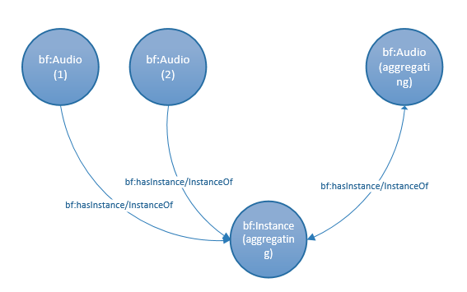

:Audio1 a bf:Audio ;
bf:hasInstance :InstanceAggregating .
:Audio2 a bf:Audio ;
bf:hasInstance : InstanceAggregating .
:AudioAggregating a bf:Audio ;
bf:hasInstance : InstanceAggregating .
: InstanceAggregating a bf:Instance ;
bf:instanceOf :Audio1 ;
bf:instanceOf :Audio2 ;
bf:instanceOf :AudioAggregating .

As an example, this would be the encoding for Lorde’s ep disc “Lorde”. The title of this sample compilation is “Lorde”, and it contains two songs: “Royals” and “Bravado” in that order.
http://libraries.stanford.edu/works/RoyalsAudio a bf:Audio ;
bf:hasInstance http://libraries.stanford.edu/instances/LordeInstance .
http://libraries.stanford.edu/works/BravadoAudio a bf:Audio ;
bf:hasInstance http://libraries.stanford.edu/instances/LordeInstance . http://libraries.stanford.edu/works/LordeAudio ; a bf:Audio ;
bf:hasInstance http://libraries.stanford.edu/instances/LordeInstance .
http://libraries.stanford.edu/instances/LordeInstance a bf:Instance ;
bf:instanceOf http://libraries.stanford.edu/works/RoyalsAudio ;
bf:instanceOf http://libraries.stanford.edu/works/BravadoAudio ;
bf:instanceOf http://libraries.stanford.edu/instances/LordeInstance .
In a PMO implementation in which the work model is extended to loosely express the work/expression differentiation, the compilation model would include this extension, moving closer to the IFLA-LRM model. In addition, the extended model should include an added property pair to link the individual aggregated expressions to the aggregating expression—pmo:aggregatedBy and pmo:aggregates—to mirror the IFLA-LRM “short-cut” model mentioned above. This “short-cut” seems to be optional in IFLA-LRM (and thus represented by dotted lines in the diagram), but seems to be a valuable relationship to encode.
The fuller model, then, would look like this:
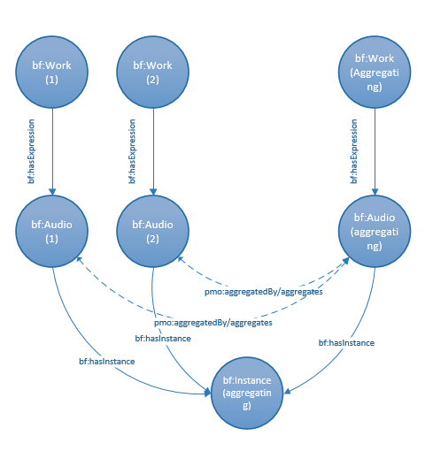
Note: From here on, properties are only given in one direction for clarity in the diagram. The inverse for each property (e.g., bf:expressionOf for bf:hasExpression) is presumed. Inverses are included in the Turtle below.

:Work1 a bf:Work ;
bf:hasExpression :Audio1 .
:Work2 a bf:Work ;
bf:hasExpression :Audio2 .
:WorkAggregating a bf:Work ;
bf:hasExpression :AudioAggregating .
:Audio1 a bf:Audio ;
bf:expressionOf :Work1 ;
bf:hasInstance :InstanceAggregating ;
pmo:aggregatedBy :AudioAggregating .
:Audio2 a bf:Audio ;
bf:expressionOf :Work2 ;
bf:hasInstance :InstanceAggregating ;
pmo:aggregatedBy :AudioAggregating .
:AudioAggregating a bf:Audio ;
bf:expressionOf :WorkAggregating ;
bf:hasInstance :InstanceAggregating ;
pmo:aggregates :Audio1 ;
pmo:aggregates :Audio2 .
:InstanceAggregating a bf:Instance ;
bf:instanceOf :Audio1 ;
bf:instanceOf :Audio2 ;
bf:instanceOf :AudioAggregating .

If we chose to catalog the Lorde example with the work/expression split, it would look like this:
http://libraries.stanford.edu/works/RoyalsWork a bf:Work ;
bf:hasExpression http://libraries.stanford.edu/works/RoyalsAudio .
http://libraries.stanford.edu/works/BravadoWork a bf:Work ;
bf:hasExpression http://libraries.stanford.edu/works/BravadoAudio .
http://libraries.stanford.edu/works/LordeWork a bf:Work ;
bf:hasExpression http://libraries.stanford.edu/works/LordeAudio .
http://libraries.stanford.edu/works/RoyalsAudio a bf:Audio ;
bf:expressionOf http://libraries.stanford.edu/works/RoyalsWork ;
pmo:aggregatedBy http://libraries.stanford.edu/works/LordeAudio ;
bf:hasInstance http://libraries.stanford.edu/instances/LordeInstance .
http://libraries.stanford.edu/works/BravadoAudio a bf:Audio ;
bf:expressionOf http://libraries.stanford.edu/works/BravadoWork ;
pmo:aggregatedBy http://libraries.stanford.edu/works/LordeAudio ;
bf:hasInstance http://libraries.stanford.edu/instances/LordeInstance . http://libraries.stanford.edu/works/LordeAudio a bf:Audio ;
bf:expressionOf http://libraries.stanford.edu/instances/LordeWork ;
pmo:aggregates http://libraries.stanford.edu/works/RoyalsAudio ;
pmo:aggregates http://libraries.stanford.edu/works/BravadoAudio ;
bf:hasInstance http://libraries.stanford.edu/instances/LordeInstance .
http://libraries.stanford.edu/instances/LordeInstance a bf:Instance ;
bf:instanceOf http://libraries.stanford.edu/works/RoyalsAudio ;
bf:instanceOf http://libraries.stanford.edu/works/BravadoAudio ;
bf:instanceOf http://libraries.stanford.edu/instances/LordeAudio .

While in the IFLA-LRM model, both the individual expressions and the aggregate expression are related to the manifestation by the property “is embodied in”, there is a question whether these two relationships are really the same. While the aggregate expression is certainly “embodied” in the manifestation, the same cannot really be said for the individual expressions. They are indeed encompassed by the aggregate manifestation, but that manifestation is not in itself truly a manifestation of the individual expression.
It is tempting to use the RDA unconstrained property rdau:P60101 “is container of” and its inverse rdau:60249 “is contained in”, continuing the terminology of current RDA cataloging to define this relationship. These properties, however, are subproperties of rdau:P60714 “has whole-part resource relationship with”, a relationship IFLA-LRM explicitly states is not applicable to aggregating expressions and their aggregated individual expressions, and so cannot be applied here. Because of this, it might be necessary to add a subproperty to bf:hasInstance called pmo:hasAggregatingInstance (and its inverse pmo:AggregatingInstanceOf) to make the relationship between the aggregated expression and the aggregating manifestation/instance clearer than what appears in the IFLA-LRM model. The resulting diagram would look like this (additional properties circled):
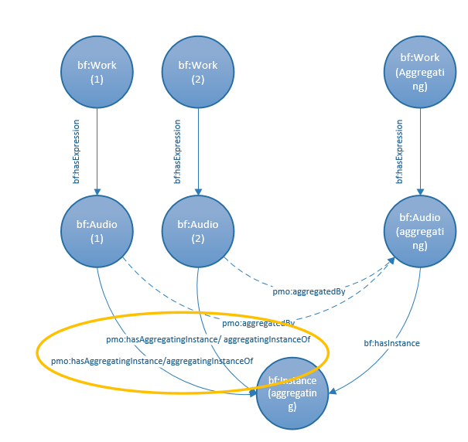

:Work1 a bf:Work ;
bf:hasExpression :Audio1 .
:Work2 a bf:Work ;
bf:hasExpression :Audio2 .
:WorkAggregating a bf:Work ;
bf:hasExpression :AudioAggregating .
:Audio1 a bf:Audio ;
bf:expressionOf :Work1 ;
pmo:hasAggregatingInstance :InstanceAggregating ;
pmo:aggregatedBy :AudioAggregating .
:Audio2 a bf:Audio ;
bf:expressionOf :Work2 ;
pmo:hasAggregatingInstance :InstanceAggregating ;
pmo:aggregatedBy :AudioAggregating .
:AudioAggregating a bf:Audio ;
bf:expressionOf :WorkAggregating ;
bf:hasInstance :InstanceAggregating ;
pmo:aggregates :Audio1 ;
pmo:aggregates :Audio2 .
:InstanceAggregating a bf:Instance ;
pmo:aggregatingInstanceOf :Audio1 ;
pmo:aggregatingInstanceOf :Audio2 ;
bf:instanceOf :AudioAggregating .

The Lorde ep would then be modeled as follows:

http://libraries.stanford.edu/works/RoyalsWork a bf:Work ;
bf:hasExpression http://libraries.stanford.edu/works/RoyalsAudio .
http://libraries.stanford.edu/works/BravadoWork a bf:Work ;
bf:hasExpression http://libraries.stanford.edu/works/BravadoAudio .
http://libraries.stanford.edu/works/LordeWork a bf:Work ;
bf:hasExpression http://libraries.stanford.edu/works/LordeAudio .
http://libraries.stanford.edu/works/RoyalsAudio a bf:Audio ;
bf:expressionOf http://libraries.stanford.edu/works/RoyalsWork ;
pmo:aggregatedBy http://libraries.stanford.edu/works/LordeAudio ;
bf:hasAggregatingInstance http://libraries.stanford.edu/instances/LordeInstance .
http://libraries.stanford.edu/works/BravadoAudio a bf:Audio ;
bf:expressionOf http://libraries.stanford.edu/works/BravadoWork ;
pmo:aggregatedBy http://libraries.stanford.edu/works/LordeAudio ;
bf:hasAggregatingInstance http://libraries.stanford.edu/instances/LordeInstance . http://libraries.stanford.edu/works/LordeAudio a bf:Audio ;
bf:expressionOf http://libraries.stanford.edu/works/LordeWork ;
pmo:aggregates http://libraries.stanford.edu/works/RoyalsAudio ;
pmo:aggregates http://libraries.stanford.edu/works/BravadoAudio ;
bf:hasInstance http://libraries.stanford.edu/instances/LordeInstance .
http://libraries.stanford.edu/instances/LordeInstance a bf:Instance ;
pmo:aggregatingInstanceOf http://libraries.stanford.edu/works/RoyalsAudio ;
pmo:aggregatingInstanceOf http://libraries.stanford.edu/works/BravadoAudio ;
bf:instanceOf http://libraries.stanford.edu/instances/LordeInstance .

While this model works in theory, there is a major weakness. Since in IFLA-LRM the aggregation takes place on the expression level and that expression is linked directly to the manifestation/instance, there is no place to add data that relates to that expression only when it is part of a specific compilation. Our primary use case for this type of data is the ordering of work/expressions on a disc (pmo:hasOrder) and track numbers (pmo:hasTrackNumber). An expression is not always aggregated, and individual works may be aggregated in different ways in different aggregations.

There are two possible solutions to this:
- Add an “aggregated expression” for every time an expression is aggregated into a new compilation.
This model retains the idea of the aggregation taking place at the expression level as above, and in IFLA-LRM, but extends it by requiring a new expression for every time that an expression is aggregated into a new compilation, even if the content of the individual expression is otherwise the same:
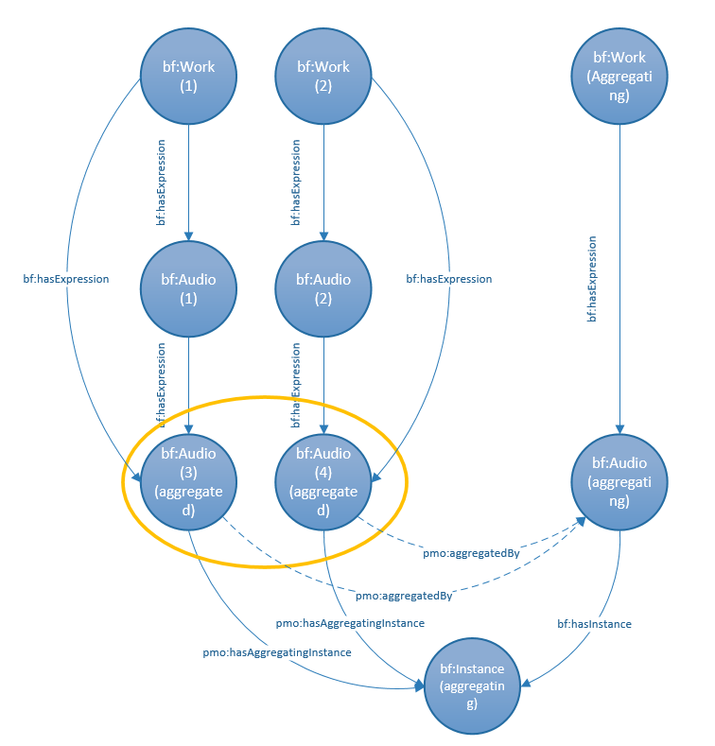

:Work1 a bf:Work ;
bf:hasExpression :Audio1 ;
bf:hasExpression :Audio3 .
:Work2 a bf:Work ;
bf:hasExpression :Audio2 ;
bf:hasExpression :Audio4 .
:Audio1 a bf:Audio ;
bf:expressionOf :Work1 ;
bf:hasExpression :Audio3 .
:Audio2 a bf:Audio ;
bf:expressionOf :Work2 ;
bf:hasExpression :Audio4 .
:Audio3 a bf:Audio ;
bf:expressionOf :Work1 ;
bf:expressionOf :Audio1 ;
pmo:aggregatedBy :AudioAggregating ;
pmo:hasAggregatingInstance :InstanceAggregating.
:Audio4 a bf:Audio ;
bf:expressionOf :Work2 ;
bf:expressionOf :Audio2 ;
pmo:aggregatedBy :AudioAggregating ;
pmo:hasAggregatingInstance :InstanceAggregating.
:WorkAggregating a bf:Work ;
bf:hasExpression :AudioAggregating .
:AudioAggregating a bf:Audio ;
bf:expressionOf :WorkAggregating ;
pmo:aggregates :Audio3 ;
pmo:aggregates :Audio4 ;
bf:hasInstance :InstanceAggregating.
:InstanceAggregating a bf:Instance ;
bf:instanceOf :AudioAggregating ;
pmo:aggregatingInstanceOf :Audio3 ;
pmo:aggregatingInstanceOf :Audio4 .

The Lorde example would be as follows:

http://libraries.stanford.edu/works/RoyalsWork a bf:Work ;
bf:hasExpression http://libraries.stanford.edu/works/RoyalsAudio ;
bf:hasExpression http://libraries.stanford.edu/works/RoyalsAudioAgg .
http://libraries.stanford.edu/works/BravadoWork a bf:Work ;
bf:hasExpression http://libraries.stanford.edu/works/BravadoAudio ;
bf:hasExpression http://libraries.stanford.edu/works/BravadoAudioAgg .
http://libraries.stanford.edu/works/LordeWork a bf:Work ;
bf:hasExpression http://libraries.stanford.edu/works/LordeAudio .
http://libraries.stanford.edu/works/RoyalsAudio a bf:Audio ;
bf:expressionOf http://libraries.stanford.edu/works/RoyalsWork ;
bf:hasExpression http://libraries.stanford.edu/works/RoyalsAudioAgg .
http://libraries.stanford.edu/works/BravadoAudio a bf:Audio ;
bf:expressionOf http://libraries.stanford.edu/works/BravadoWork ;
bf:hasExpression http://libraries.stanford.edu/works/BravadoAudioAgg .
http://libraries.stanford.edu/works/RoyalsAudioAgg a bf:Audio ;
bf:expressionOf http://libraries.stanford.edu/works/RoyalsWork ;
bf:expressionOf http://libraries.stanford.edu/works/RoyalsAudio ;
pmo:aggregatedBy http://libraries.stanford.edu/works/LordeAudio ;
bf:hasAggregatingInstance http://libraries.stanford.edu/instances/LordeInstance .
http://libraries.stanford.edu/works/BravadoAudio a bf:Audio ;
bf:expressionOf http://libraries.stanford.edu/works/BravadoWork ;
bf:expressionOf http://libraries.stanford.edu/works/BravadoAudioAgg ;
pmo:aggregatedBy http://libraries.stanford.edu/works/LordeAudio ;
pmo:hasAggregatingInstance http://libraries.stanford.edu/instances/LordeInstance . http://libraries.stanford.edu/works/LordeAudio a bf:Audio ;
bf:expressionOf http://libraries.stanford.edu/works/RoyalsWork ;
pmo:aggregates http://libraries.stanford.edu/works/RoyalsAudioAgg ;
pmo:aggregates http://libraries.stanford.edu/works/BravadoAudioAgg ;
bf:hasInstance http://libraries.stanford.edu/instances/LordeInstance .
http://libraries.stanford.edu/instances/LordeInstance a bf:Instance ;
pmo:aggregatingInstanceOf http://libraries.stanford.edu/works/RoyalsAudioAgg ;
pmo:aggregatingInstanceOf http://libraries.stanford.edu/works/BravadoAudioAgg ;
bf:instanceOf http://libraries.stanford.edu/works/LordeAudio .

Note that the aggregated expression (in the diagram Audio3 and Audio4) may be linked directly to the generic bf:Work with the property bf:hasExpression and/or link to the un-aggregated bf:Audio/expression of that same work.
With the addition of the individual aggregated expression, it is then possible to add properties that apply only to that expression as it appears in a compilation such as order or track numbering (only one individual work shown here for clarity):

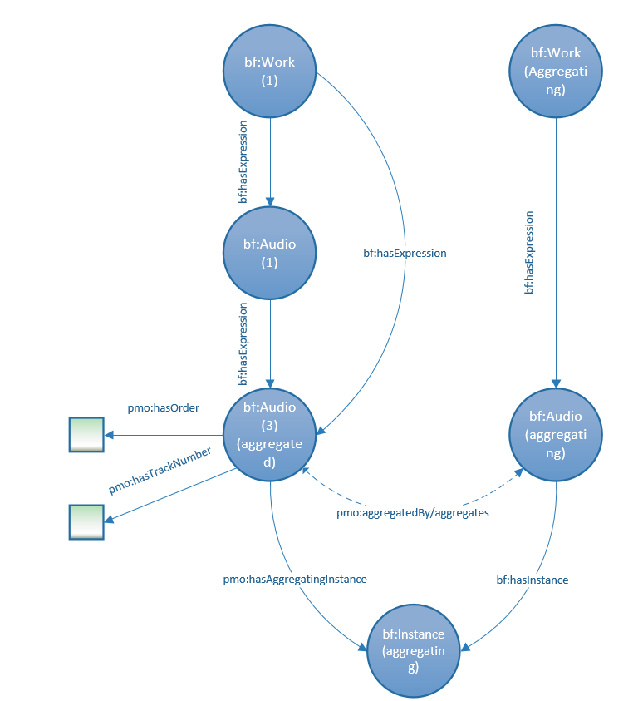
:Work1 a bf:Work ;
bf:hasExpression :Audio1 ;
bf:hasExpression :Audio3 .
:Audio1 a bf:Audio ;
bf:expressionOf :Work1 ;
bf:hasExpression :Audio3 .
:Audio3 a bf:Audio ;
bf:expressionOf :Work1 ;
bf:expressionOf :Audio1 ;
pmo:aggregatedBy :AudioAggregating ;
pmo:hasAggregatingInstance :InstanceAggregating ;
pmo:hasOrder [number] ;
pmo:hasTrackNumber [number] .
:WorkAggregating a bf:Work ;
bf:hasExpression :AudioAggregating .
:AudioAggregating a bf:Audio ;
bf:expressionOf :WorkAggregating ;
pmo:aggregates :Audio3 ;
bf:hasInstance :InstanceIntegrating.
:InstanceAggregating a bf:Instance ;
bf:instanceOf :AudioAggregating ;
pmo:aggregatingInstanceOf :Audio3 .
The Lorde example:

http://libraries.stanford.edu/works/RoyalsWork a bf:Work ;
bf:hasExpression http://libraries.stanford.edu/works/RoyalsAudio ;
bf:hasExpression http://libraries.stanford.edu/works/RoyalsAudioAgg .
http://libraries.stanford.edu/works/LordeWork a bf:Work ;
bf:hasExpression http://libraries.stanford.edu/works/LordeAudio .
http://libraries.stanford.edu/works/RoyalsAudio a bf:Audio ;
bf:expressionOf http://libraries.stanford.edu/works/RoyalsWork ;
bf:hasExpression http://libraries.stanford.edu/works/RoyalsAudioAgg .
http://libraries.stanford.edu/works/RoyalsAudioAgg a bf:Audio ;
bf:expressionOf http://libraries.stanford.edu/works/RoyalsWork ;
bf:expressionOf http://libraries.stanford.edu/works/RoyalsAudio ;
pmo:aggregatedBy http://libraries.stanford.edu/works/LordeAudio ;
pmo:hasOrder “1” ;
pmo:hasTrackNumber “1” ;
bf:hasAggregatingInstance http://libraries.stanford.edu/instances/LordeInstance .
http://libraries.stanford.edu/works/LordeAudio a bf:Audio ;
bf:expressionOf http://libraries.stanford.edu/works/RoyalsWork ;
pmo:aggregates http://libraries.stanford.edu/works/RoyalsAudioAgg ;
bf:hasInstance http://libraries.stanford.edu/instances/LordeInstance .
http://libraries.stanford.edu/instances/LordeInstance a bf:Instance ;
pmo:aggregatingInstanceOf http://libraries.stanford.edu/works/RoyalsAudioAgg ;
bf:instanceOf http://libraries.stanford.edu/works/LordeAudio .

- Create a true aggregate bf:Instance in which each individual expression has an individual instance which is aggregated into the aggregating instance.
In this scenario, each individual bf:Work has its own separate bf:Instance which would be encompassed by the aggregate bf:Instance. In this case, information about order and track numbers would reside with the individual instance, which seems more logical. It would also have the benefit of allowing the modeling of relationships between the individual instance in the aggregate and other instances. Some examples of this include: the relationship between an instance on a sampler disc and the instance in the pubished disc; and the original recording on a wax cylinder and the individual release of that instance in a CD compilation of wax cylinder recordings).
In this model, there is no need for the property pmo:hasAggregatingInstance. Instead, pmo:aggregateIn and pmo:aggregates move to the instance level, linking the instances of the individual works with the aggregating instance:
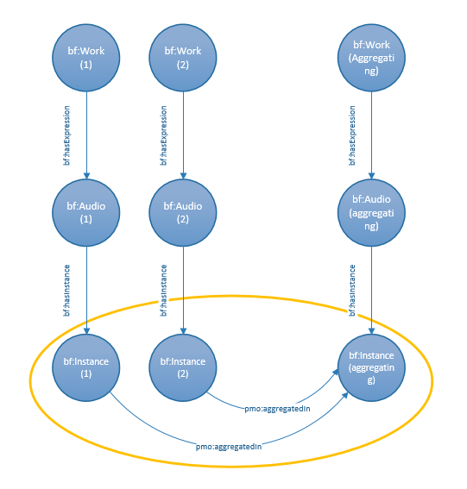
:Work1 a bf:Work ;
bf:hasExpression :Audio1 ;
:Work2 a bf:Work ;
bf:hasExpression :Audio2.
:Audio1 a bf:Audio ;
bf:expressionOf :Work1 ;
bf:hasInstance :Instance1 .
:Audio2 a bf:Audio ;
bf:expressionOf :Work2 ;
bf:hasInstance :Instance2.
:Instance1 a bf:Instance ;
bf:instanceOf :Audio1 ;
pmo:aggregatedIn :InstanceAggregating .
:Instance2 a bf:Instance ;
bf:instanceOf :Audio2 ;
pmo:aggregatedIn :InstanceAggregating .
:WorkAggregating a bf:Work ;
bf:hasExpression :AudioAggregating .
:AudioAggregating a bf:Audio ;
bf:expressionOf :WorkAggregating ;
bf:hasInstance :InstanceAggregating .
:InstanceAggregating a bf:Instance ;
bf:instanceOf :AudioAggregating ;
pmo:aggregates :Instance1 ;
pmo:aggregates :Instance 2 .

The Lorde example:

http://libraries.stanford.edu/works/RoyalsWork a bf:Work ;
bf:hasExpression http://libraries.stanford.edu/works/RoyalsAudio .
http://libraries.stanford.edu/works/BravadoWork a bf:Work ;
bf:hasExpression http://libraries.stanford.edu/works/BravadoAudio .
http://libraries.stanford.edu/works/LordeWork a bf:Work ;
bf:hasExpression http://libraries.stanford.edu/works/LordeAudio .
http://libraries.stanford.edu/works/RoyalsAudio a bf:Audio ;
bf:expressionOf http://libraries.stanford.edu/works/RoyalsWork ;
bf:hasInstance http://libraries.stanford.edu/instances/RoyalsInstance .
http://libraries.stanford.edu/works/BravadoAudio a bf:Audio ;
bf:expressionOf http://libraries.stanford.edu/works/BravadoWork ;
bf:hasInstance http://libraries.stanford.edu/instances/BravadoInstance .
http://libraries.stanford.edu/works/LordeAudio a bf:Audio ;
bf:expressionOf http://libraries.stanford.edu/works/LordeWork ;
bf:hasInstance http://libraries.stanford.edu/instances/LordeInstance .
http://libraries.stanford.edu/instances/RoyalsInstance a bf:Instance ;
bf:instanceOf http://libraries.stanford.edu/works/RoyalsAudio ;
pmo:aggregatedBy http://libraries.stanford.edu/instances/LordeInstance .
http://libraries.stanford.edu/instances/BravadoInstance a bf:Instance ;
bf:instanceOf http://libraries.stanford.edu/works/BravadoAudio ;
pmo:aggregatedBy http://libraries.stanford.edu/instances/LordeInstance .
http://libraries.stanford.edu/instances/LordeInstance a bf:Instance ;
pmo:aggregates http://libraries.stanford.edu/instances/RoyalsInstance ;
pmo:aggregates http://libraries.stanford.edu/instances/BravadoInstance ;
bf:instanceOf http://libraries.stanford.edu/works/LordeAudio .

In this case the order and track numbers can be applied to each individual instance within the aggregate instance (only one aggregated instance given here).

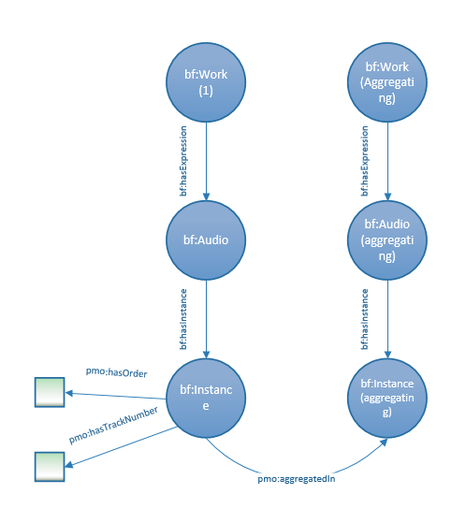
:Work1 a bf:Work ;
bf:hasExpression :Audio1 ;
:Audio1 a bf:Audio ;
bf:expressionOf :Work1 ;
bf:hasInstance :Instance1 .
:Instance1 a bf:Instance ;
bf:instanceOf :Audio1 ;
pmo:aggregatedIn :InstanceAggregating ;
pmo:hasOrder [number] ;
pmo:hasTrackNumber [number] .
:WorkAggregating a bf:Work ;
bf:hasExpression :AudioAggregating .
:AudioAggregating a bf:Audio ;
bf:expressionOf :WorkAggregating ;
bf:hasInstance :InstanceAggregating .
:InstanceAggregating a bf:Instance ;
bf:instanceOf :AudioAggregating ;
pmo:aggregates :Instance1 .

http://libraries.stanford.edu/works/RoyalsWork a bf:Work ;
bf:hasExpression http://libraries.stanford.edu/works/RoyalsAudio .
http://libraries.stanford.edu/works/BravadoWork a bf:Work ;
bf:hasExpression http://libraries.stanford.edu/works/BravadoAudio .
http://libraries.stanford.edu/works/LordeWork a bf:Work ;
bf:hasExpression http://libraries.stanford.edu/works/LordeAudio .
http://libraries.stanford.edu/works/RoyalsAudio a bf:Audio ;
bf:expressionOf http://libraries.stanford.edu/works/RoyalsWork ;
bf:hasInstance http://libraries.stanford.edu/instances/RoyalsInstance .
http://libraries.stanford.edu/works/BravadoAudio a bf:Audio ;
bf:expressionOf http://libraries.stanford.edu/works/BravadoWork ;
bf:hasInstance http://libraries.stanford.edu/instances/BravadoInstance .
http://libraries.stanford.edu/works/LordeAudio a bf:Audio ;
bf:expressionOf http://libraries.stanford.edu/works/LordeWork ;
bf:hasInstance http://libraries.stanford.edu/instances/LordeInstance .
http://libraries.stanford.edu/instances/RoyalsInstance a bf:Instance ;
bf:instanceOf http://libraries.stanford.edu/works/RoyalsAudio ;
pmo:aggregatedBy http://libraries.stanford.edu/instances/LordeInstance
pmo:hasOrder “1” ;
pmo:hasTrackNumber “1” .
http://libraries.stanford.edu/instances/BravadoInstance a bf:Instance ;
bf:instanceOf http://libraries.stanford.edu/works/BravadoAudio ;
pmo:aggregatedBy http://libraries.stanford.edu/instances/LordeInstance ;
pmo:hasOrder “2” :
pmo:hasTrackNumber “2” .
http://libraries.stanford.edu/instances/LordeInstance a bf:Instance ;
pmo:aggregates http://libraries.stanford.edu/instances/RoyalsInstance ;
pmo:aggregates http://libraries.stanford.edu/instances/BravadoInstance ;
bf:instanceOf http://libraries.stanford.edu/works/LordeAudio .

Summation of Possible Added Properties

Property | Definition | Solution number
pmo:hasAggregatingInstance | Links an individual work/expression to an aggregating instance in a compilation. | 1
pmo:aggregatesInstance | Links an aggregating instance to an individual work it aggregates into a compilation.
pmo:aggregatedIn | Links an individual instance to an aggregating expression (solution 1) or an aggregating instance (solution 2) in which it is compiled. | 2
pmo:aggregates | Links an aggregating instance to an expression (solution 1) or instance (solution 2) that it aggregates. | 2
pmo:hasOrder | Order a compiled work/expression has in a compilation or a work component in a work. | Both
pmo:hasTrackNumber | Track numbers of a compiled work/expression in a compilation | Both

As of January 2018. The RDA registry has not been available, as it is being updated.

